Group id : 6

Project Name : Stock Candle

**Assignment 9**

Title: Prepare a Block/ Architecture Diagram

Problem Statement: Identify Blocks of your system and draw the diagram using proper

notations.

Theory : \

Block diagram

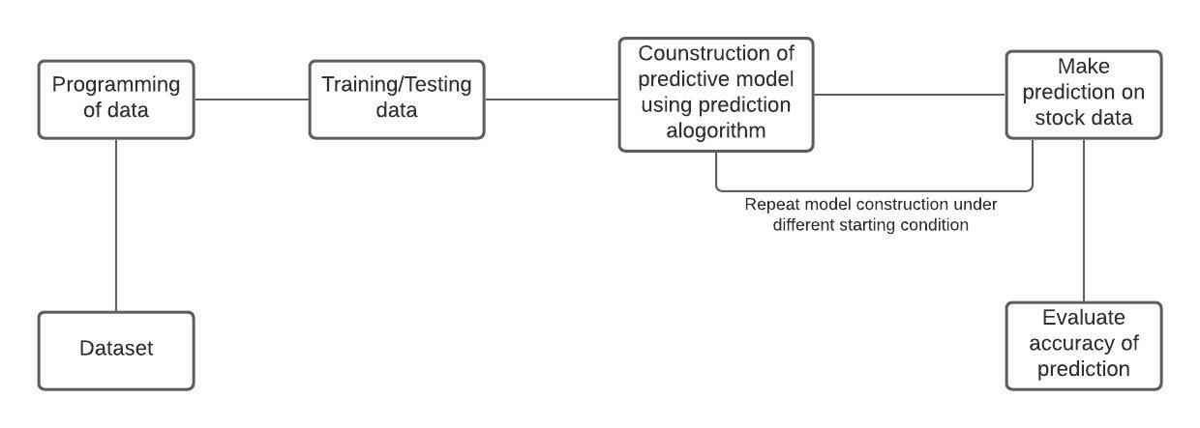

**Conclusion :** Thus, we have prepared block diagram using lucid chart.